Ex. No. 2 | ADAPTIVE AND RESPONSIVE UI DESIGN
Date of Exercise
Git Hub Host Link | https://github.com/Karthikeyan-0/flutter.git

Aim
To create a Flutter application that automatically adapts its layout according to the available screen size.

Description
This experiment demonstrates adaptive and responsive UI design in Flutter using Layout Builder. The application displays a Column layout for smaller screens such as mobile devices and a Row layout for larger screens such as tablets and desktops.

Procedure:
- Create a new Flutter project using the following commands: flutter create responsive_ui
cd responsive_ui
code .
- Run the Flutter application using: flutter run
- Open the lib/main.dart file.
- Use LayoutBuilder to check the available screen width.
- If the screen width is less than 600 pixels, display the mobile layout using Column.
- If the screen width is 600 pixels or greater, display the desktop/tablet layout using Row.
- Add Card and ListTile widgets to display Students and Courses.
- Run the application and resize the browser window or use different emulator sizes.
- Verify that the layout automatically changes between Column and Row according to the screen size.

Program
import 'package:flutter/material.dart';

void main() {
runApp(const ResponsiveUI());
}

class ResponsiveUI extends StatelessWidget { const ResponsiveUI({super.key});

@override
Widget build(BuildContext context) { return MaterialApp( debugShowCheckedModeBanner: false, home: Scaffold(
appBar: AppBar(
title: const Text('Responsive UI'),
),
body: LayoutBuilder(
builder: (context, constraints) {
if (constraints.maxWidth < 600) { return Column(
children: [ Card(
child: ListTile(
title: const Text('Students'),
),
),
Card(
child: ListTile(
title: const Text('Courses'),
),
),
],

);
}
return Row( children: [ Expanded(
child: Card( child: ListTile(
title: const Text('Students'),
),
),
),
Expanded( child: Card(
child: ListTile(
title: const Text('Courses'),
),
),
),
],
);
},
),
),
);
}
}

Output

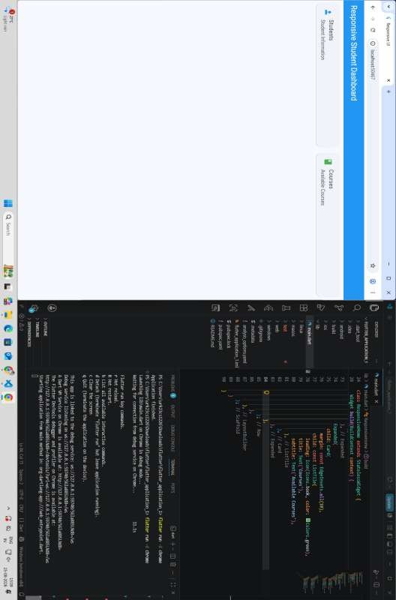

Result
Thus, the Flutter application was successfully developed with an adaptive and responsive user interface. The layout automatically changes from Column on smaller screens to Row on larger screens according to the available screen size.

Ex. 2 | Title of exercise
1

